TULIP
Tenant Users Liability Insurance Policy

Corporation of the Catholic Archbishop of Seattle Tenant users may obtain a quote from Intact Entertainment TULIP/GatherGuard without obligation to buy by doing the following:
- Visit the TULIP/GatherGuard website at https://gatherguard.com/
- Click Get a Quote
- Pick your event (there is a drop-down menu that you may use to pick event, if needed)
- Answer questions on next screen and press continue
- Click the Use Venue Code box. Then type in the venue code of the location for your event and click Next.
  - This code will be given to you from your archdiocese contact – or you may find it on the archdiocese insurance website in the TULIP section.
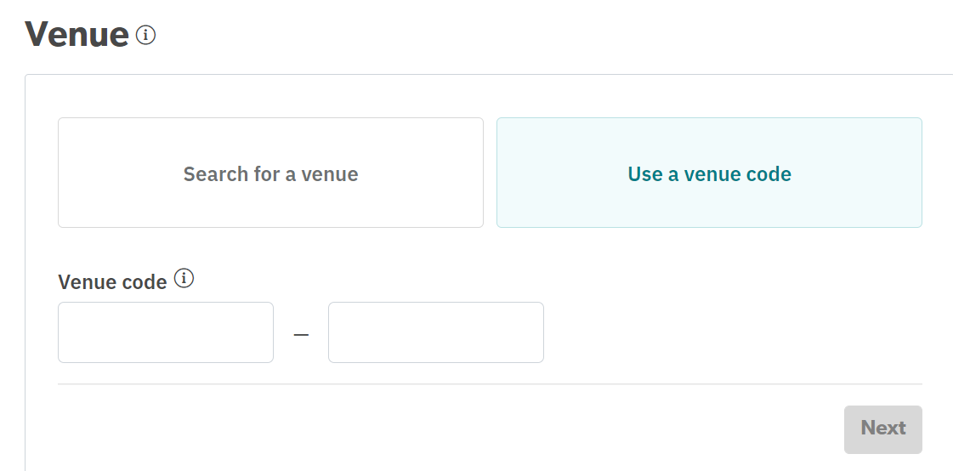
- The following few screens will go through insurance options and dates etc. Please answer all to obtain a quote.
  - Basic Coverage and additional coverage to bring Damage to Rented Premises Limit to $1 million will be checked and are mandatory
- If you are ready to purchase, please click Checkout and pay with a credit card.
  - A copy of the insurance certificate should be given to the archdiocese event location
- Should you require further assistance please call the Intact Entertainment TULIP/GatherGuard help desk at (844) 747-6240.

